VISION AND INFRA-RED SENSOR BASED FIRE FIGHTING ROBOT

Mr.R.Velanth  
*Assistant Professor*   
*Department of Electronics and Instrumentation Engineering*   
*Bannari Amman Institute of Technology*Sathyamangalam, India   
[velnath@bitsathy.ac.in](mailto:velnath@bitsathy.ac.in)

Mr.M.Karthik  
II *Year Student*   
*Department of Electronics and Instrumentation Engineering*   
*Bannari Amman Institute of Technology*Sathyamangalam, India   
[karthik.ei19@bitsathy.ac.in](mailto:karthik.ei19@bitsathy.ac.in) Ms.R.Srimathi  
II *Year Student*   
*Department of Electronics and Instrumentation Engineering*   
*Bannari Amman Institute of Technology*Sathyamangalam, India  
 [srimathi.ei19@bitsathy.ac.in](mailto:srimathi.ei19@bitsathy.ac.in)

Mr.B.Kumaresan  
II *Year Student*   
*Department of Electronics and Instrumentation Engineering*   
*Bannari Amman Institute of Technology*Sathyamangalam, IndiaCity, Country  
[kumaresan.ei19@bitsathy.ac.in](mailto:kumaresan.ei19@bitsathy.ac.in) Ms. J.S. Jegadeeswari   
II *Year Student*   
*Department of Electronics and Instrumentation Engineering*   
*Bannari Amman Institute of Technology*Sathyamangalam, India   
[jegadeeswari.ei19@bitsathy.ac.in](mailto:jegadeeswari.ei19@bitsathy.ac.in)

Mr.G.Saravana  
II *Year Student*   
*Department of Electronics and Instrumentation Engineering*   
*Bannari Amman Institute of Technology*Sathyamangalam, India   
[saravana.ei19@bitsathy.ac.in](mailto:saravana.ei19@bitsathy.ac.in)

*Abstract*— A machine that can perform a complicated series of tasks automatically “and “A machine that is made to look like a human and that can do some things that a human can do” – These are the defining terms found in the entry against the word ‘ROBOT’ in the famous ‘Oxford Advanced Learner’s Dictionary of current English’ by Astheny. Robot is a system containing sensors, control systems, manipulations, power suppliers and software – all working together like an organized team effort to perform a task. Fire-fighting robots are useful in situations where it is too difficult to extinguish fire. It is also be very useful in situations where fire fighters have difficulty in reaching the place which is of fire and to be extinguished. Modular design based on proximity, vision and IR sensors has been incorporated into a fire-fighting model. The robot has a sprinkler in it and it is useful in extinguishing flame by sprinkling water in the place of fire. Software consists of integrated tracking, obstacle avoidance, flame detection, motion algorithms and detection. Through testing, it is possible to run in a realistic scene simulated in the lab and to detect and extinguishment the flame. Robot can transfer video to remote location.

Keywords— Infra-red sensor, Flame Detection, Transmitter and receiver.

# Introduction

Robots are deployed in various industries and for consumer applications. The fire-fighting robot is one of the most autonomous mobile robots in the world and has a significant and very useful application in the future. They can be deployed at close quarters and where it is too dangerous accessible. The existing model of modern fire-fighting robots are using blowers to extinguish the fire. This fire-fighting strategy works well in some fire-fighting robot applications. However, it's not only inefficient in practical scenarios, but in some cases, it's possible to further inflame the hearth . The use of water or other flame retardant liquid to extinguish the fire is used in real life scenario and have also been used in this work. The water spray firefighting robot will require precise localization of the fire and placement of robotic arm. In order to catch up on the positioning error caused by tracking and stopping, this work incorporates the arm above the smart car, winding the arm round the pipe, and installing the nozzle at the arm end, so as to expand the work area by swinging the arm during the firefighting operation. The purpose of this project is to design and develop an experimental modular intelligent fire extinguishing robot designed to run a patrol on a planned trajectory, detect the fire autonomously, locate it and extinguish the flame by water spray. It simulates the scenes of warehouses, laboratories, storage rooms, cargo hold and cabin of aircraft. Making use of the mobility of robots, it eliminates the deficiencies of traditional fixed base fire detectors and fire extinguishing

❖ To detect fire in the disaster-hit area.

❖ To provide indications both audio and visual.

❖ To extinguish fire as soon as it is detected .

❖ To reduce the efforts of human labour and the level

of destruction as well and thereby prevent a major

fire disaster

❖ Design and development of low cost firefighting

robot.

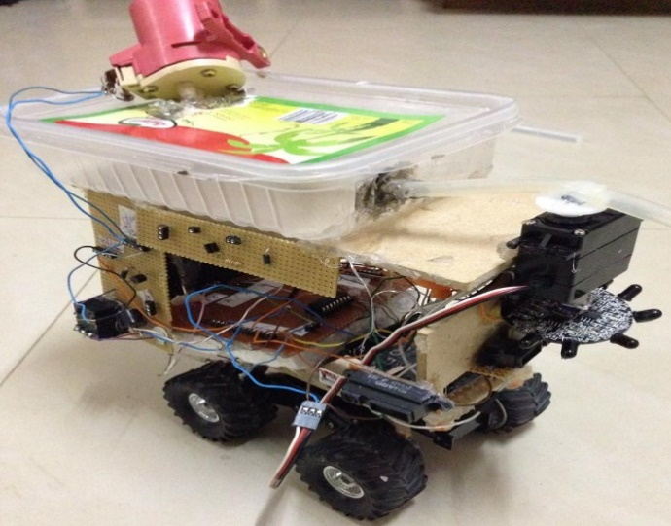

1. Model of a fire fighting robot

⮚ Design a firefighting robot using numerical

Approach

⮚ Select the suitable material to develop the robot.

⮚ The developing of programming is necessary to develop a mechanism of the robot.

# LITERATURE SURVEY

## Survey of a Firefighting Robot:

In today’s era, many authors enhance their new technologies to work on Fire Fighting Robot. Author Kristi Kokasih et al. has established intelligent Fire Fighting tank robot. Tank robot is built by acrylic, plastic, iron and aluminum. Components of this Robot are two servo motors, two DC motors, ultrasonic sensor, compass sensors, flame sensor detector, thermal sensor, white detector-IR and photo transistor, sound activation circuit sensor and micro switch sensor. The purpose of this Robot is to search certain area, find and blow out the flame for different flame positions, room configuration with disturbance. Robot is operated through DTMF transmitter and receiver.

Author, H.P. Singh et al has developed Control of an Autonomous Industrial Fire Fighting Robot. The paper relates the establishment and sketch of mobile Fire Fighting Robot. The approach contains two optically isolated D.C. motors. Robot bring off analog to digital conversion of the data delivered by infrared sensors. Five infrared sensors are used. Two infrared sensors have the power to control the motion of the robots and three infrared sensors are for flame detection. The essential feature of the robot is to recognize the flames of fire and quench it. The fire extinguisher made up of D.C water pump and water container. The microcontroller controls the snuff out extinguishing system. Infrared sensor is used as input sensor which senses the infrared rays leak out of the fire. Remote Controlled Fire Fighting Robot developed by Author Phyo Wai Aung tell off the functions of remote-control Fire Fighting Robot. It consists of two main parts that is transmitter and receiver, in that major parts two sets of RF modules are suited. One RF module is accustomed to transfer the data to the motor driver module, another RF module is accustomed to realize the state on fire. Microcontroller PIC16F887 is used to handle the entire process of the Fire Fighting Robot. The motors of the Robot are driven by the L298 and ULN2003 drivers in this system. The operator curbed the robot by using wireless camera mounted on the robot. If the temperature of fire spot is more than 40 degree Celsius, the alarm will be ringing so that operator can curb the Fire Fighting Robot and keep away from the damage of heat.

## Conventional method:

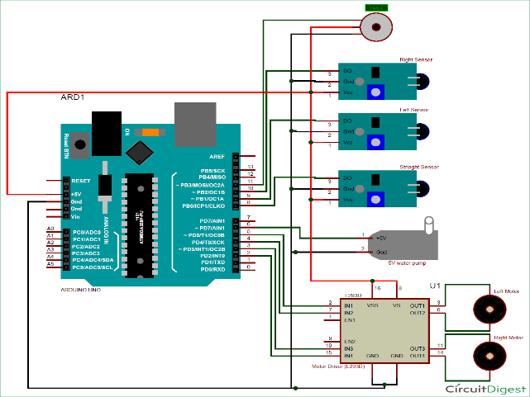

1. Model of a Conventional Circuit Diagram Using Arduino

# Proposed Method

The proposed method has the following components as listed below,

*Components:*

✔ Smoke sensor

✔ Temperature sensor

✔ Flame sensor

✔ PIC 16 F73

✔ Motor driver and geared DC motor.

✔ Relay

✔ Led

✔ Pump

## Steps of building the module:

* Movement step.
* Flame tracking step.
* Extinguishing Fire step.

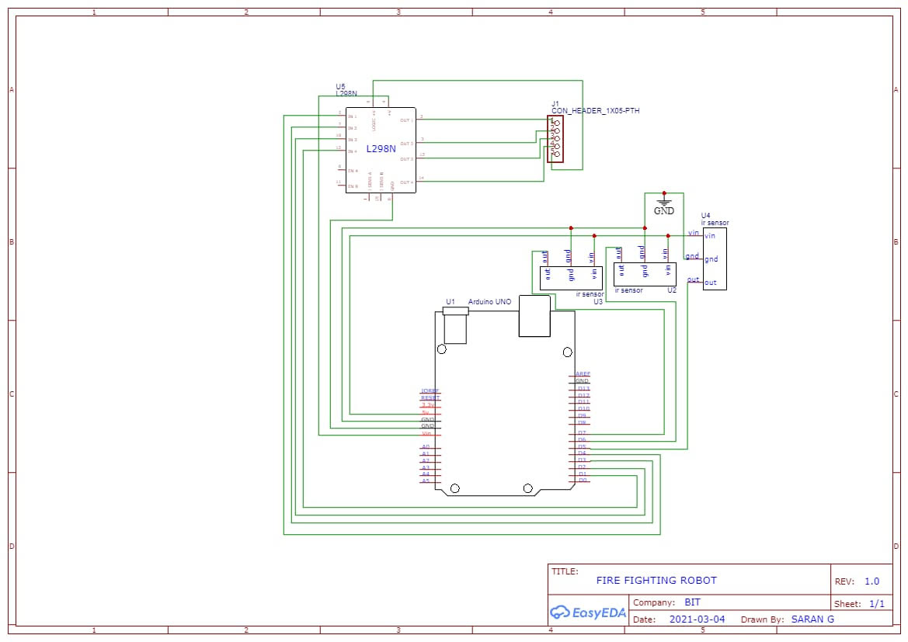

1. a.Proposed Flow Chart

## Proposed ALGORITHM:

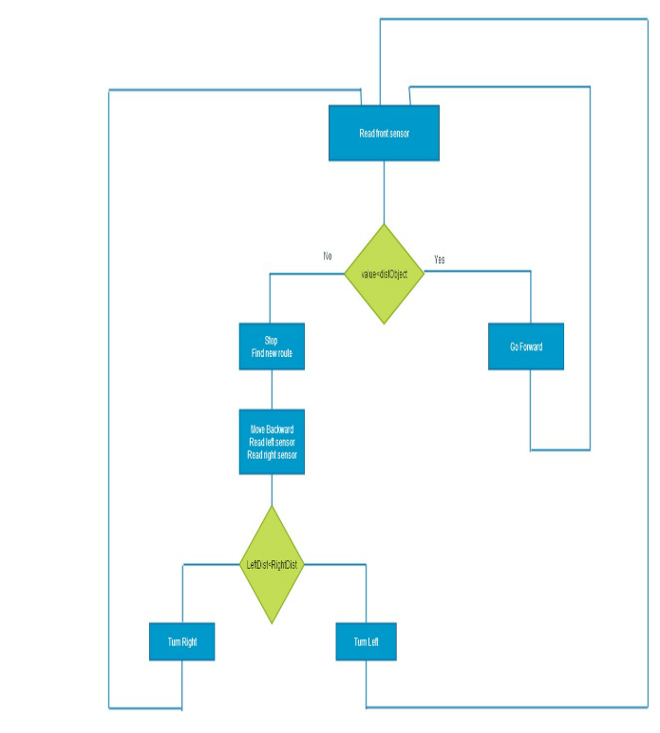

1. b.Proposed Flow Chart

*Movement step:*

* Read from front sensor if it’s less than specified value go forward. Else stop and find new route.
* Find new route by going backward .Read left and right sensors. If left distance less than right distance then turn left else turn right.
* Go back to first step.

## Working of Smoke Sensor:

smoke is a colloid substance comprising a collection of airborne particles both solid and liquid and the gases emitted there from are injurious to health. Smoke is an unwanted, or rather, harmful or injurious by-product of fire. Detecting the smoke, the smoke sensor provides output to the MCU.

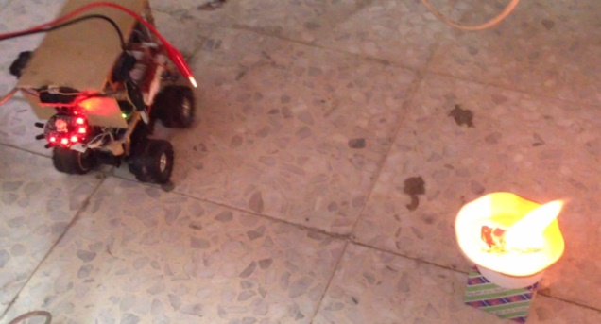

1. Working of a Smoke Sensor

## Temperature Sensor:

Using transducers, the temperature at the site of disaster is measured. Electrical output is given out to the already existing temperature. Output voltage is proportional to the Celsius temperature. Flame sensor A sensor designed to detect and respond to the presence of a flame or fire serves as a flame detector. A flame sensor can detect flame or fire at a wave length 750nm. It can detect flame at a distance of 20cm. Its detection angle is 60 degrees. It has adjustable sensitivity. The voltage it requires for operation is from 3.3 to 5v. With the view of avoiding damage, the flame sensor is kept at a safe distance away from fire.

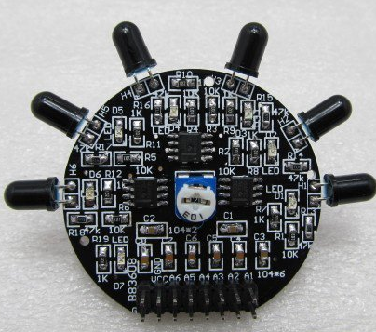

1. Schematic of a Infra-Red Sensor

## Microcontroller –PIC 16 F73:

Taking or reading the data from the sensors, all the functions of the whole system are controlled by way of manipulating the data. The movement of robot is controlled. In case the sensor outputs exceed the preset value, the presence of fire is indicated and the water pump mechanism is immediately operated by the MCU. Motor driver and geared DC motor. An interface between the 5V logic signal from the microcontroller and the high current / high voltage power is provided to drive the motor. Motor being an electromechanical device, it converts electrical energy into rotation i.e., mechanical energy. With a view to drive the robotic vehicle, DC geared motor is put into use.

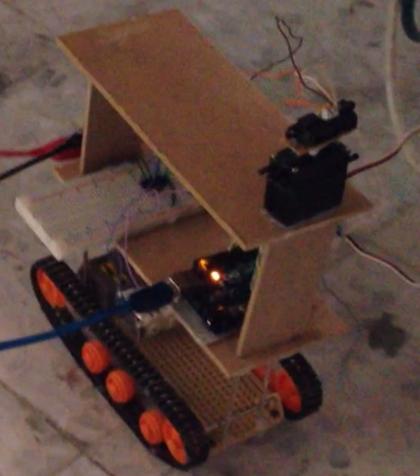

1. Complete Setup of a Infra-Red Sensor Based Fire Robot

*F. Visual Indicators :*

Differently-coloured LEDs are used to indicate the conditions of the sensors. If any of the sensor outputs goes high, MCU will turn on the audio alarm in order to intimate the fact to the other ones. Relay and driver circuits. For the purpose of connecting a relay with any microcontroller,interfacing is required. Relays are inductive loads by which water pumps are controlled . Between relays and processor pins is fixed the driving circuit. In order to boost current the output of the microcontroller is fed to the relay driver and the relay is thus magnetized by the output.

# *G.Water pump:*

Water pump is used to pump water in case any abnormal condition arises in the system. Whenever an excess of temperature or smoke or flame is detected, the water pump will immediately start pumping water.

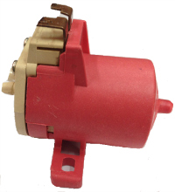

1. Water Pump Used in Firefighting Robot

# Results and Discussion:

The output of the firefighting robot will be like, when the sensor detects flame it will automatically reaches the place of fire. At the instance of sensing fire, the led will blink and the buzzer will be on which will indicate that the fire has been taken place. When the robot reaches near the place of fire the sprinkler gets on and it will rotate at 360°. The water gets splashed and the fire will be extinguished.

# Conclusion

The exact direction, or rather, the very location of the source of fire is easily as well as clearly detected.

⮚ Capability of accurate sensing is assured with increased flexibility.

⮚ The vital advantage is the reduction of human effort and manual labor which can play only a secondary or supporting role during the time of such exigency.

⮚ Besides being trustworthy, it is economical too.

⮚ It is neither sensitive to nor affected by varied weather conditions.

# Future Scope

In Future, the firefighting robot can be made by nano materials and polymer coatings which has a high temperature resistance. It can also be made of gps and gsm system in which message and the place of fire accident is shared for the fire station and the concerned owner. Therefore, the robot can be made to work with fire fighters to avoid major injury and loss of properties.

# Reference:

1. Gerald Weed, Michael Schumacher, Shawn McVay, Jack Landes “PPPPokey The Fire-Fighting Robot. A Logical Design Using Digital and Analog Circuitry”, May 11 1999.
2. William Dubel, Hector Gongora, Kevin, “Rolly Firefighter Robot”, Florida International University, Miami, 2003.
3. John Holland, “Designing Autonomous Mobile Robots”, Elsevier Inc, 2004
4. C. Shaohua, B. Hong, Z. Xianyun, and Y. Yimin, "A Fire Detecting Method Based on Multi-Sensor Data Fusion," In Systems, Man and Cybernetics, 2003.IEEE International Conference on, 2003, pp. 3775-3780 vol.4.K.
5. T. Cheng-Hung, B. Ying-Wen, C. Chun-An, C. Chih-Yu, and L. Ming-Bo,"PIR-Sensor-Based Lighting Device with Ultra-Low Standby Power Consumption," in Instrumentation and Measurement Technology Conference (I2MTC), 2011 IEEE, 2011, pp. 1-6.